Christmas Eve Service
Thursday, December 24, 2020

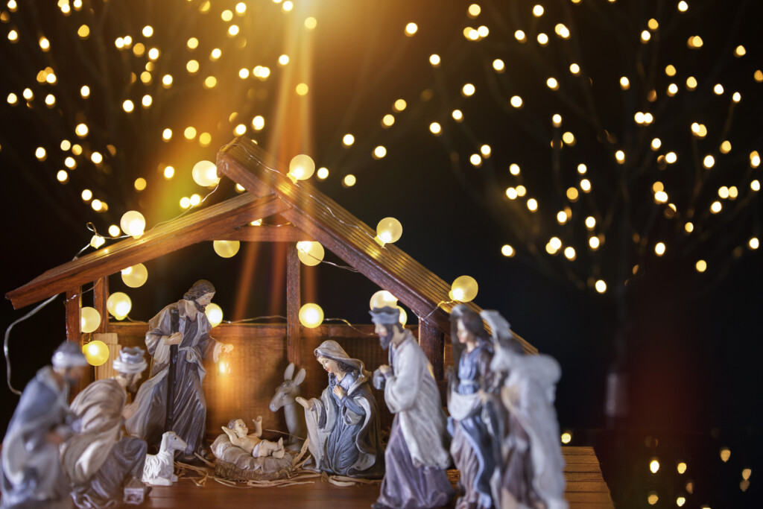

Episcopal Church Of St. Thomas
111 High Street, Taunton, MA 02780
www.StThomasTaunton.com
E-Mail: StThomasEpiscopalChurch@Comcast.net

Hymn: 83 “O come, all ye faithful”

O come, all ye faithful,
joyful and triumphant,
O come ye, O come ye to Bethlehem;
come, and behold him,
born the King of angels;

O come, let us adore him,
Christ the Lord.

Sing, choirs of angels,
sing in exultation,
sing, all ye citizens of heav’n above:
“Glory to God,
all glory in the highest!” [Refrain]

Yea, Lord, we greet thee,
born this happy morning;
Jesus, to thee be glory given;
Word of the Father,
now in flesh appearing; Refrain

The people standing, the Celebrant says
Celebrant For a child has been born for us, a son given to us;
People authority rests upon his shoulders;
Celebrant and he is named Wonderful Counselor, Mighty God,
People Everlasting Father, Prince of Peace.

The Celebrant says
Almighty God, to you all hearts are open, all desires known, and from you no secrets are hid: Cleanse the thoughts of our hearts by the inspiration of your Holy Spirit, that we may perfectly love you, and worthily magnify your holy Name; through Christ our Lord. Amen.
The following is sung, all standing

“A Christmas Gloria” Gloria in excelsis Deo
Collect of the Day

Celebrant The Lord be with you.
People And also with you.
Celebrant Let us pray.

Almighty God, you have given your only-begotten Son to take our nature upon him, and to be born this day of a pure virgin: Grant that we, who have been born again and made your children by adoption and grace, may daily be renewed by your Holy Spirit; through our Lord Jesus Christ, to whom with you and the same Spirit be honor and glory, now and for ever. Amen.

First Reading Isaiah 9:2-4,6-7
The people who walked in darkness have seen a great light; those who lived in a land of deep darkness—on them light has shined. You have multiplied the nation, you have increased its joy; they rejoice before you as with joy at the harvest, as people exult when dividing plunder. For the yoke of their burden, and the bar across their shoulders, the rod of their oppressor, you have broken as on the day of Midian. For a child has been born for us, a son given to us; authority rests upon his shoulders; and he is named Wonderful Counselor, Mighty God, Everlasting Father, Prince of Peace. His authority shall grow continually, and there shall be endless peace for the throne of David and his kingdom. He will establish and uphold it with justice and with righteousness from this time onward and forevermore. The zeal of the Lord of hosts will do this.
Reader The Word of the Lord.
People Thanks be to God.

Psalm 96
1 Sing to the Lord a new song; *
sing to the Lord, all the whole earth.
2 Sing to the Lord and bless his Name; *
proclaim the good news of his salvation from day to day.
3 Declare his glory among the nations *
and his wonders among all peoples.
4 For great is the Lord and greatly to be praised; *
he is more to be feared than all gods.
5 As for all the gods of the nations, they are but idols; *
but it is the Lord who made the heavens.
6 Oh, the majesty and magnificence of his presence! *
Oh, the power and the splendor of his sanctuary!
7 Ascribe to the Lord, you families of the peoples; *
ascribe to the Lord honor and power.
8 Ascribe to the Lord the honor due his Name; *
bring offerings and come into his courts.
9 Worship the Lord in the beauty of holiness; *
let the whole earth tremble before him.
10 Tell it out among the nations: "The Lord is King! *
he has made the world so firm that it cannot be moved;
he will judge the peoples with equity."
11 Let the heavens rejoice, and let the earth be glad;
let the sea thunder and all that is in it; *
let the field be joyful and all that is therein.
12 Then shall all the trees of the wood shout for joy
before the Lord when he comes, *
13 He will judge the world with righteousness *
and the peoples with his truth.
Second Reading Titus 2:11-14

The grace of God has appeared, bringing salvation to all, training us to renounce impiety and worldly passions, and in the present age to live lives that are self-controlled, upright, and godly, while we wait for the blessed hope and the manifestation of the glory of our great God and Savior, Jesus Christ. He it is who gave himself for us that he might redeem us from all iniquity and purify for himself a people of his own who are zealous for good deeds.
Reader The Word of the Lord.
People Thanks be to God.

Gospel Acclamation: Alleluia! Alleluia! Alleluia! Alleluia!

Holy Gospel Luke 2:1-4(15-20)

All stand and turn to face the Gospel
Celebrant The Holy Gospel of our Lord Jesus Christ according to Luke.
People Glory to you, Lord Christ.

In those days a decree went out from Emperor Augustus that all the world should be registered. This was the first registration and was taken while Quirinius was governor of Syria. All went to their own towns to be registered. Joseph also went from the town of Nazareth in Galilee to Judea, to the city of David called Bethlehem, because he was descended from the house and family of David. He went to be registered with Mary, to whom he was engaged and who was expecting a child. While they were there, the time came for her to deliver her child. And she gave birth to her firstborn son and wrapped him in bands of cloth, and laid him in a manger, because there was no place for them in the inn. In that region there were shepherds living in the fields, keeping watch over their flock by night. Then an angel of the Lord stood before them, and the glory of the Lord shone around them, and they were terrified. But the angel said to them, "Do not be afraid; for see-- I am bringing you good news of great joy for all the people: to you is born this day in the city of David a Savior, who is the Messiah, the Lord. This will be a sign for you: you will find a child wrapped in bands of cloth and lying in a manger." And suddenly there was with the angel a multitude of the heavenly host, praising God and saying, "Glory to God in the highest heaven, and on earth peace among those whom he favors!"[When the angels had left them and gone into heaven, the shepherds said to one another, "Let us go now to Bethlehem and see this thing that has taken place, which the Lord has made known to us." So they went with haste and found Mary and Joseph, and the child lying in the manger. When they saw this, they made known what had been told them about this child; and all who heard it were amazed at what the shepherds told them. But Mary treasured all these words and pondered them in her heart. The shepherds returned, glorifying and praising God for all they had heard and seen, as it had been told them.]

Celebrant The Gospel of the Lord.
People Praise to you, Lord Christ.

Sermon: The Rev. Joseph Mumita
Nicene Creed

All stand.
We believe in one God,
the Father, the Almighty,
maker of heaven and earth,
of all that is, seen and unseen.
We believe in one Lord, Jesus Christ,
the only Son of God,
eternally begotten of the Father,
God from God, Light from Light,
true God from true God,
begotten, not made,
of one Being with the Father.
Through him all things were made.
For us and for our salvation
he came down from heaven:
by the power of the Holy Spirit
he became incarnate from the Virgin Mary,
and was made man.
For our sake he was crucified under Pontius Pilate;
he suffered death and was buried.
On the third day he rose again
in accordance with the Scriptures;
he ascended into heaven
and is seated at the right hand of the Father.
He will come again in glory to judge the living and the dead,
and his kingdom will have no end.
We believe in the Holy Spirit, the Lord, the giver of life,
who proceeds from the Father and the Son.
With the Father and the Son he is worshiped and glorified.
He has spoken through the Prophets.
We believe in one holy catholic and apostolic Church.
We acknowledge one baptism for the forgiveness of sins.
We look for the resurrection of the dead,
and the life of the world to come. Amen.

Prayers of the People
In peace, we pray to you, Lord God.
Silence
For all people in their daily life and work;
For our families, friends, and neighbors, and for those who are alone.
For this community, the nation, and the world;
For all who work for justice, freedom, and peace.
For the just and proper use of your creation;
For the victims of hunger, fear, injustice, and oppression.
For all who are in danger, sorrow, or any kind of trouble;
For those who minister to the sick, the friendless, and the needy.
For the peace and unity of the Church of God;
For all who proclaim the Gospel, and all who seek the Truth.

For Michael our Presiding Bishop, for Alan our Diocesan Bishop and Gayle our Bishop Suffragan and for all bishops and other Ministers.
For all who serve God in his Church.
For the special needs and concerns of this congregation.
Silence
The People may add their own petitions
Hear us, Lord;
For your mercy is great.
We thank you, Lord, for all the blessings of this life.
Silence
The People may add their own thanksgivings
We will exalt you, O God our King;
And praise your Name for ever and ever.
We pray for all who have died, that they may have a place in your eternal kingdom.
Silence
The People may add their own petitions
We pray to you also for the forgiveness of our sins.

Silence may be kept.

Leader and People

Have mercy upon us, most merciful Father;
in your compassion forgive us our sins,
known and unknown,
things done and left undone;
and so uphold us by your Spirit
that we may live and serve you in newness of life,
to the honor and glory of your Name;
through Jesus Christ our Lord, Amen.

The Priest stands and says

Almighty God have mercy on you, forgive you all your sins through our Lord Jesus Christ, strengthen you in all goodness, and by the power of the Holy Spirit keep you in eternal life. Amen.

Peace
All stand.

Celebrant The peace of the Lord be always with you.
People And also with you.

Then the Ministers and the People may greet one another in the name of the Lord.

Holy Communion

The Celebrant says

Walk in love, as Christ loved us and gave himself for us, an offering and sacrifice to God. Ephesians 5:2

Offertory: 111 “Silent night, holy night”

1 Silent night, holy night,
all is calm, all is bright
round yon virgin mother and child.
Holy infant, so tender and mild,
sleep in heavenly peace.

2 Silent night, holy night,
shepherds quake at the sight,
glories stream from heaven afar,
heavenly hosts sing alleluia;
Christ, the Savior, is born!

3 Silent night, holy night,
Son of God, love’s pure light
radiant beams from thy holy face,
with the dawn of redeeming grace,
Jesus, Lord, at thy birth.

The people remain standing.
Celebrant The Lord be with you.
People And also with you.
Celebrant Lift up your hearts.
People We lift them to the Lord.
Celebrant Let us give thanks to the Lord our God.
People It is right to give him thanks and praise.

The Celebrant proceeds
It is right, and a good and joyful thing, always and everywhere to give thanks to you, Father Almighty, Creator of heaven and earth because you sent your beloved Son to redeem us from sin and death, and to make us heirs in him of everlasting life; that when he shall come again in power and great triumph to judge the world, we may without shame or fear rejoice to behold his appearing.
Therefore we praise you, joining our voices with Angels and Archangels and with all the company of heaven, who for ever sing this hymn to proclaim the glory of your Name:
Celebrant and People

Holy, holy, holy Lord, God of power, God of might,
heaven and earth are full of your glory.
Hosanna in the highest.
Blessed is he who comes in the name of the Lord.
Hosanna in the highest.

We give thanks to you, O God, for the goodness and love which you have made known to us in creation; in the calling of Israel to be your people; in your Word spoken through the prophets; and above all in the Word made flesh, Jesus, your Son. For in these last days you sent him to be incarnate from the Virgin Mary, to be the Savior and Redeemer of the world. In him, you have delivered us from evil, and made us worthy to stand before you. In him, you have brought us out of error into truth, out of sin into righteousness, out of death into life.
On the night before he died for us, our Lord Jesus Christ took bread; and when he had given thanks to you, he broke it, and gave it to his disciples, and said, “Take, eat: This is my Body, which is given for you. Do this for the remembrance of me.” After supper he took the cup of wine; and when he had given thanks, he gave it to them, and said, “Drink this, all of you: This is my Blood of the new Covenant, which is shed for you and for many for the forgiveness of sins. Whenever you drink it, do this for the remembrance of me.”
Therefore, according to his command, O Father,

We remember his death,
We proclaim his resurrection,
We await his coming in glory.

The Celebrant continues
And we offer our sacrifice of praise and thanksgiving to you, O Lord of all; presenting to you, from your creation, this bread and this wine.
We pray you, gracious God, to send your Holy Spirit upon these gifts that they may be the Sacrament of the Body of Christ and his Blood of the new Covenant. Unite us to your Son in his sacrifice, that we may be acceptable through him, being sanctified by the Holy Spirit. In the fullness of time, put all things in subjection under your Christ, and bring us to that heavenly country where, with all your saints, we may enter the everlasting heritage of your sons and daughters; through Jesus Christ our Lord, the firstborn of all creation, the head of the Church, and the author of our salvation.
By him, and with him, and in him, in the unity of the Holy Spirit all honor and glory is yours, Almighty Father, now and for ever. Amen
The Celebrant then continues
As our Savior Christ
has taught us,
we are bold to say,

People and Celebrant
Our Father, who art in heaven,
hallowed be thy Name,
thy kingdom come,
thy will be done,
on earth as it is in heaven.
Give us this day our daily bread.
And forgive us our trespasses,
as we forgive those
Who trespass against us.
And lead us not into temptation,
but deliver us from evil.
For thine is the kingdom,
and the power, and the glory,
For ever and ever. Amen

Breaking of the Bread
A period of silence is kept.
Alleluia. Christ our Passover is sacrificed for us;
Therefore let us keep the feast. Alleluia.
The Celebrant says
The Gifts of God for the People of God.
All baptized persons regardless of denomination are welcome to receive Holy Communion.
Communion Hymn: 115 “What child is this/Child of the poor”

Helpless and hungry, lowly He lies, wrapped in the chill of mid-winter;
Comes now among us, born into poverty's embrace, new life for the world.
Who is this who lives with the lowly, sharing their sorrows, knowing their hunger?
This is Christ, revealed to the world in the eyes of a child, a child of the poor.

What Child is this, Who laid to rest, On Mary's lap is sleeping?
Whom Angels greet with anthems sweet, while shepherds watch are keeping?
This, this is Christ the King, whom shepherds guard and angels sing;
Haste, haste to bring Him laud, the babe the son of Mary.

Who is the stranger, here in our midst, looking for shelter among us?
Who is this outcast? Who do we see amid the poor, the children of God?
Who is this who lives with the lowly, sharing their sorrows, knowing their hunger?
This is Christ, revealed to the world in the eyes of a child, a child of the poor.

After Communion, the Celebrant says
Let us pray.
Almighty and everliving God,
we thank you for feeding us
with the spiritual food
of the most precious Body and Blood
of your Son our Savior Jesus Christ;
and for assuring us in these holy mysteries
that we are living members of the Body of your Son,
and heirs of your eternal kingdom.
And now, Father, send us out
to do the work you have given us to do,
to love and serve you
as faithful witnesses of Christ our Lord.
To him, to you, and to the Holy Spirit,
be honor and glory, now and for ever. Amen.

Hymn: 87 “Hark! The herald angels sing”
1 Hark! the herald angels sing
glory to the newborn King!
Peace on earth and mercy mild,
God and sinners reconciled!
Joyful, all ye nations, rise,
join the triumph of the skies;
with the angelic host proclaim
Christ is born in Bethlehem!

Hark! the herald angels sing
glory to the newborn King!

2 Christ, by highest heaven adored;
Christ, the everlasting Lord;
late in time behold him come,
offspring of the Virgin’s womb.
Veiled in flesh the Godhead see;
hail the incarnate Deity.
Pleased as man with man to dwell;
Jesus, our Emmanuel!

Refrain

3 Mild he lays his glory by,
born that we no more may die,
born to raise us from the earth,
born to give us second birth.
Risen with healing in his wings,
light and life to all he brings,
hail, the Sun of Righteousness!
hail, the heaven-born Prince of Peace!

Refrain

Christmas Blessing
May Christ, who by his Incarnation gathered into one things earthly and heavenly, fill you with his joy and peace; and the blessing of God Almighty, the Father, the Son, and the Holy Spirit, be among you, and remain with you always. Amen.

Dismissal
Celebrant Let us go forth in the name of Christ.
People Thanks be to God.

Christmas Day Memorials:

In loving memory of James & Beatrice Ann Taylor; Gordon & Ella Cleathero by the Cleathero Family; Gordon, Frances, William, Joanne & Gordon Steeves, Jr. & Walter & Patricia Brown by Family. Memorial Tribute in loving memory of John Pollard by Audrey Pollard; Clara Grace; Robert & Gladys Farrar by Robert & David Farrar; Joseph & Anna Betz by Joe & Barbara Betz; Barbara & Rod Sears by Barbara Wojtkiewicz; Edith Dunne & Herbert Holt.

Poinsettias: In loving memory of parents & grandparents – Russ & Doris Borden, George & Ella Cleathero; Muriel Cleathero; Bill Giles; & Susan (Tidd) Wentz by Dave & Judy Cleathero; Kris, Greg, Kati & Jill Sethares; Kim, Gunnar, Austin & Bryant Salkind; Kirk, Dawn, Parker & Camden Cleathero; Karl, Melissa, Brooke, Nathan & Emma Cleathero & Beverly Cleathero; In loving memory of Harold R. Dyke by his Wife & Family; In loving memory of loved ones and in thanksgiving of their families by Tad & Marie Largey; White Poinsettias in loving memory of loved ones by Rick & Sandi Mongiovi;

Candles:
In loving memory of George & Doris Dyke & Herbert & Lily Holt by Brian Dyke.

Rev. Crum Scholarship Fund:
In loving memory of Harold R. Dyke, Missing Friends & Loves Ones by Brian & Cheryl Dyke.

Organ Maintenance Fund:
In loving memory of Lisa Compton Bellocchio by Brian Dyke.

Buzz Perrin Fund:
In loving memory of Mr. & Mrs. Francis Benedetti & Mr. Eugene Bessette by the Boudreau Family.

Heating Oil:
In loving memory of Mr. & Mrs. Walter Lawless & Mr. & Mrs. Antoine Boudreau by the Boudreau Family.

